While studying English, I faced some problems that I think it can be improved with a better tool. I think the main problem is lack of communication and discipline with the teachers. Be inspired by this web site: <https://practicepteonline.com/ielts-listening-test-1/>, I think there are so many things that can be done to to provide a better experience and service for students and teachers.

I decided to develop a website and a mobile to fill those gaps. My project is still far from perfect, there are many features which can be done. Especially the content of the website and the needs of teachers and students.

Below is the features of the website:

1. We have a login function, user can login with a provided account or with Facebook or Google Account.

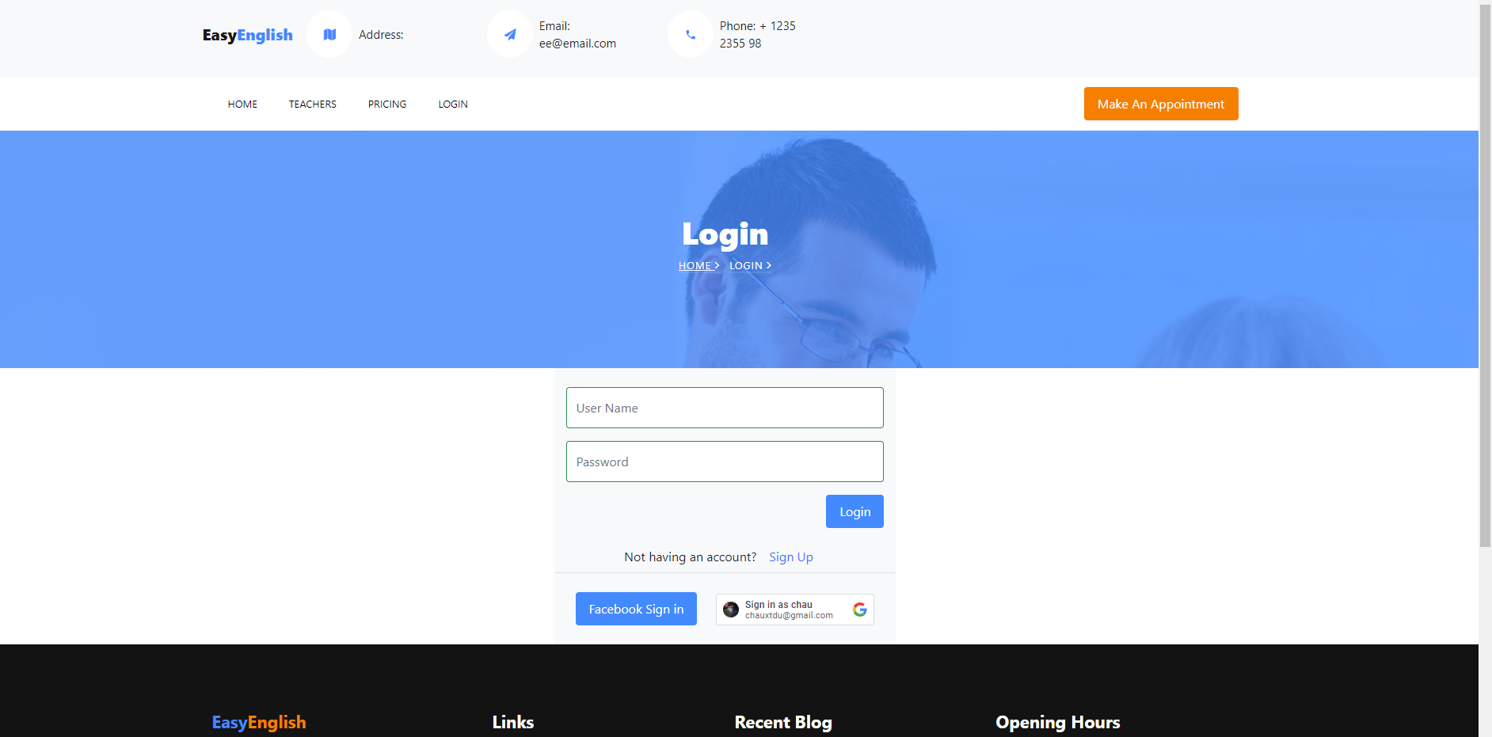

1. Signup with new account.

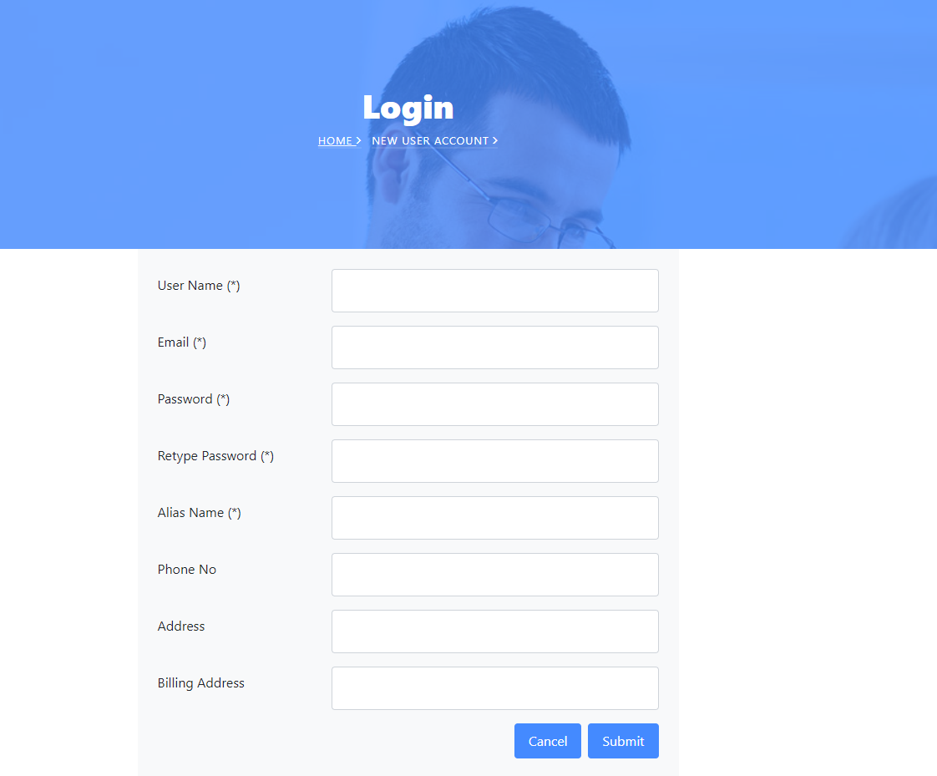

1. Home Page which provided a list of IELTS tests and lessons

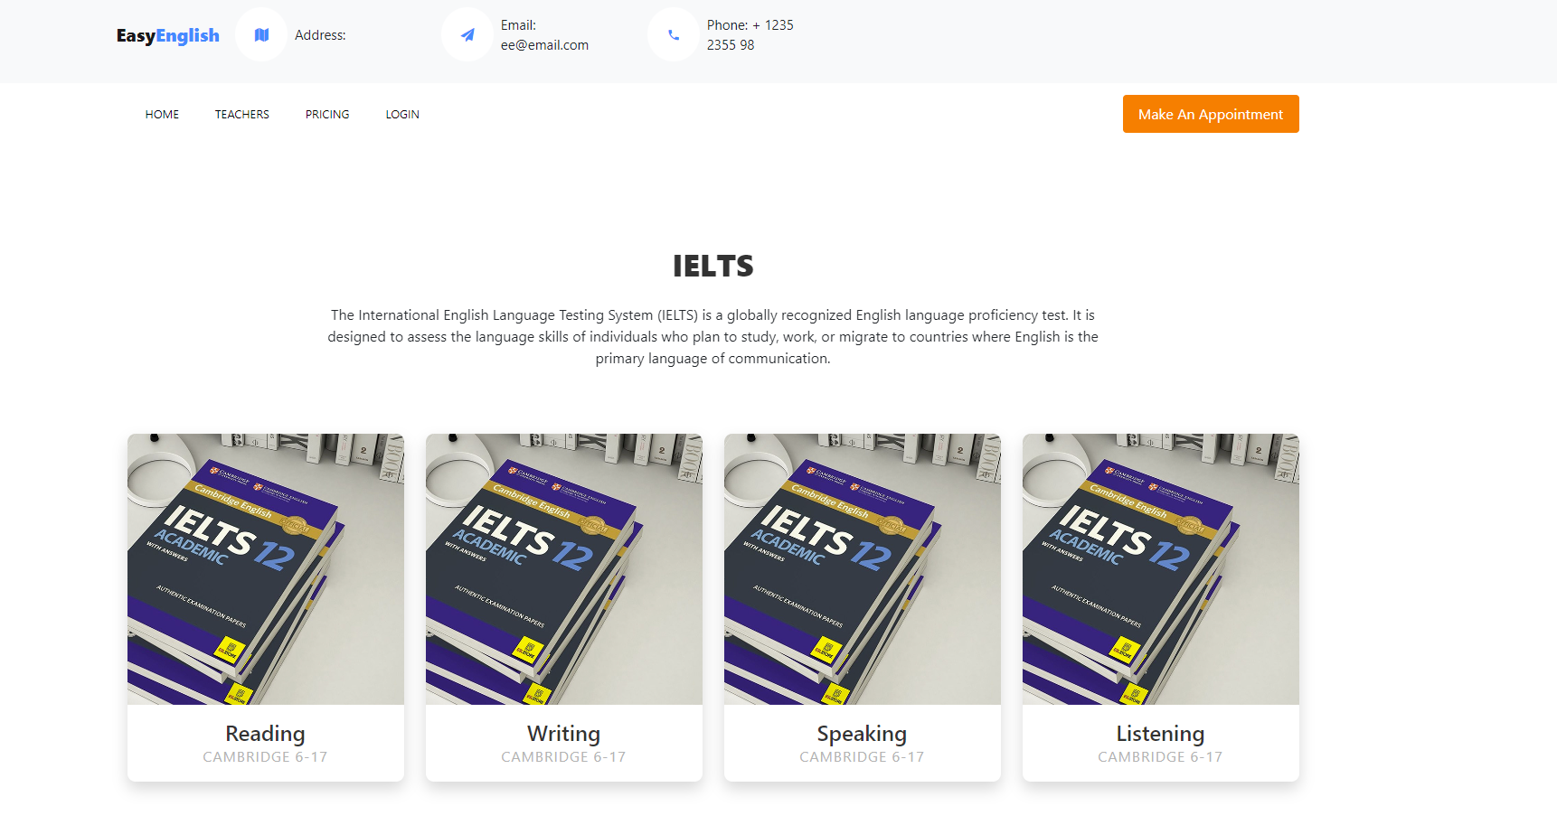

1. After access Reading Tests (or Writing/Speaking/Listening), you will have a list of tests

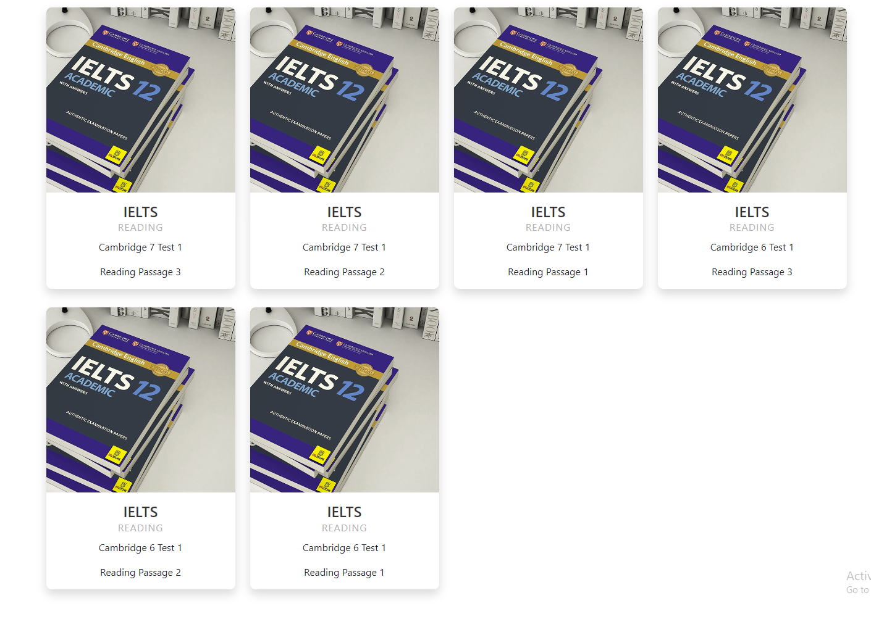

Then you can Start a test, marked it as your favorite, bookmarked or done. (You might already do it and don’t want to do it again).

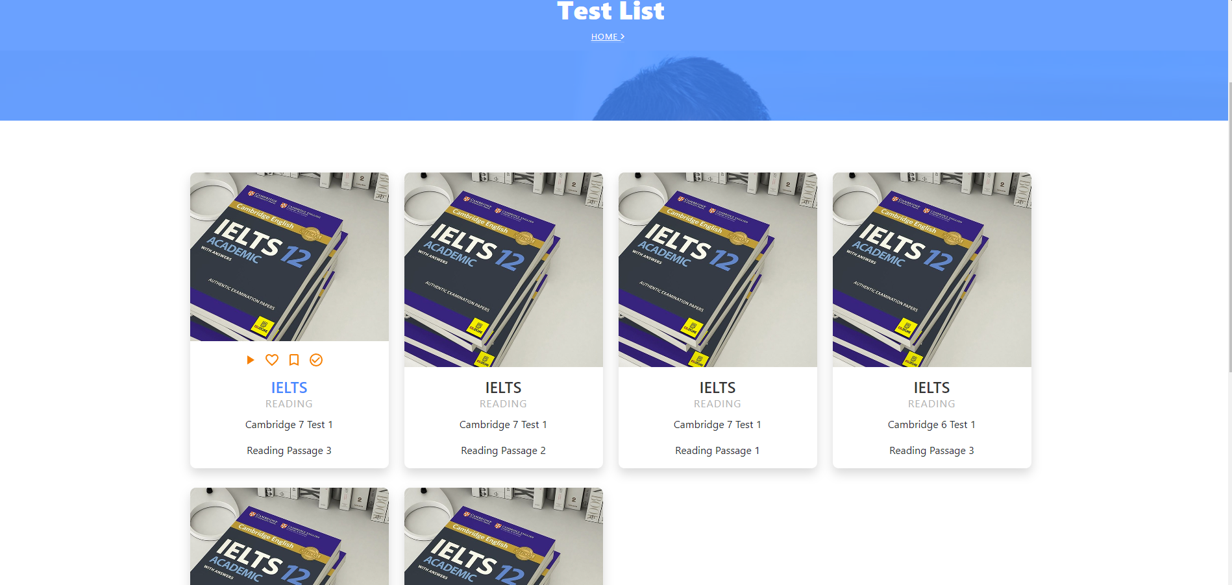

5. This is the screen when you start a reading test which allows you to mimic the real test. You can submit the test and see the result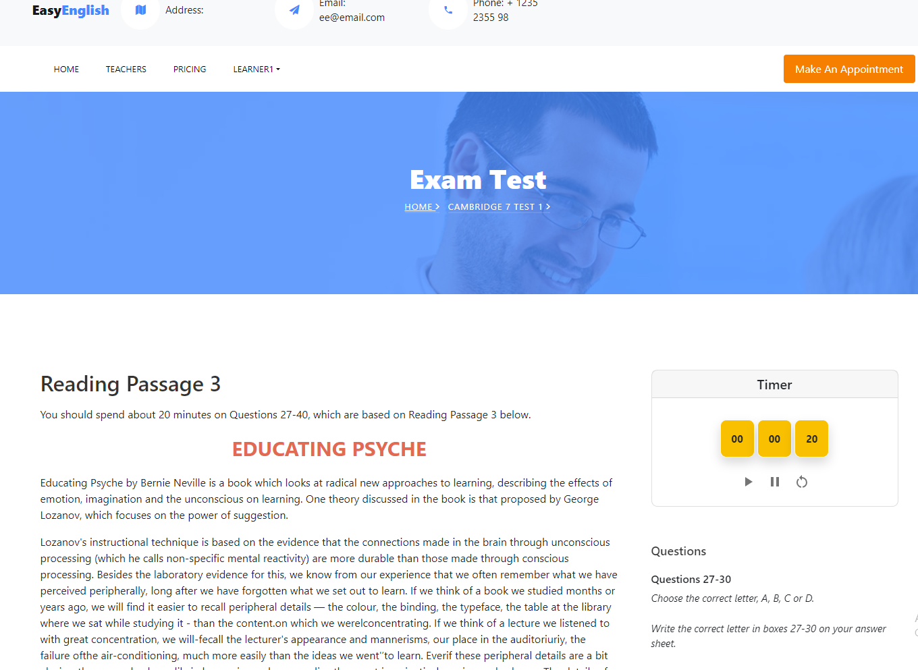

6. Students can give comments or take notes. Everyone can see your comments but only you and your teacher can see your notes. Note is an effective function that allows you to communicate with your teacher to raise questions or concerns about the tests. Based on that, teachers can provide feedback and help you to learn how to fix those problems. (Teacher may realize you have systematic grammar/vocabulary issues.)

This is the wring test: you can perform the writing task here with the help of timer and word count to mimic the real test atmosphere.

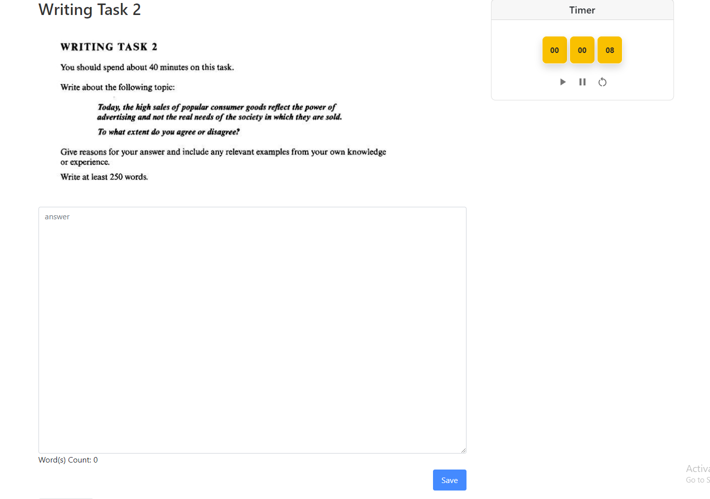

This is the speaking test, you can record your test. You and your teachers can hear it later.

And Of course, Listening test:

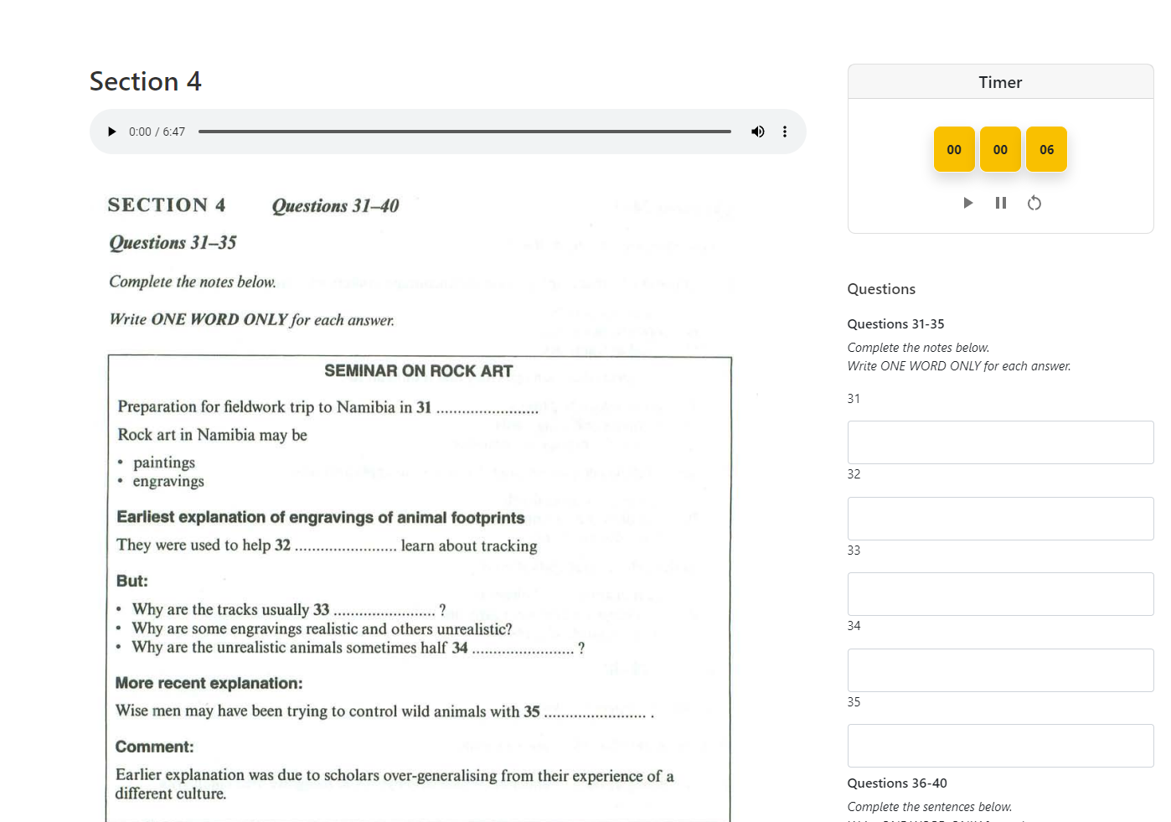

7. The system has 3 different role models: Admin, Teacher, Student. As a student you can take tests and manage your study and teachers:

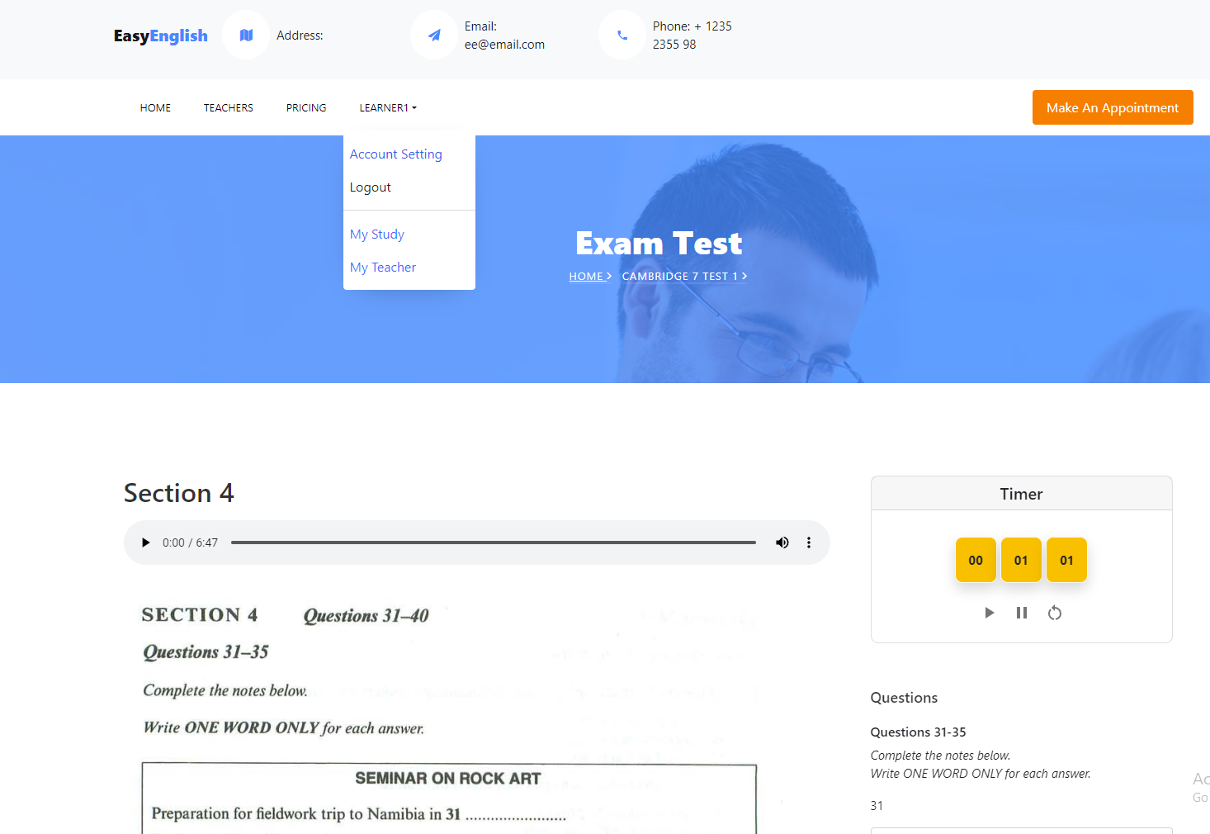

This is the MyStudy Page. In this page your can view the tests that you bookmarked as your favorite, bookmarked, assigned (tests or lessons teachers give it to you so you have to practice to improve your skills), and done (tests you have already done.)A screenshot of a computer

With the tests that you have already one, you can view your last results and the feedback that the teacher gives you so you can learn from your mistakes. This setup will track your work and follow up with your teacher.

Reading Tests

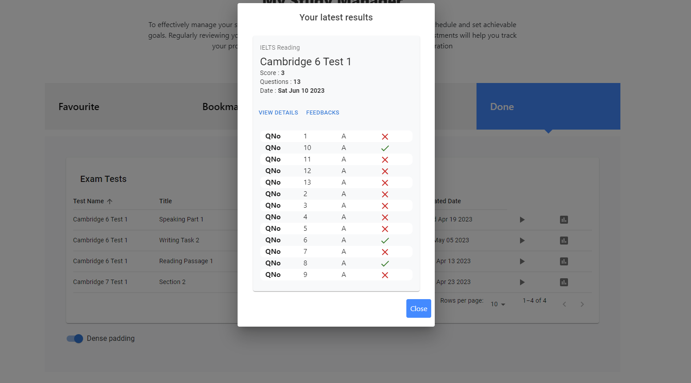

Listening Tests

Writing Tests

Speaking Tests

For the My Teacher Page: You can decide to work with available teachers on the system (this function may be used to provide bills and fees for teachers in the future.)

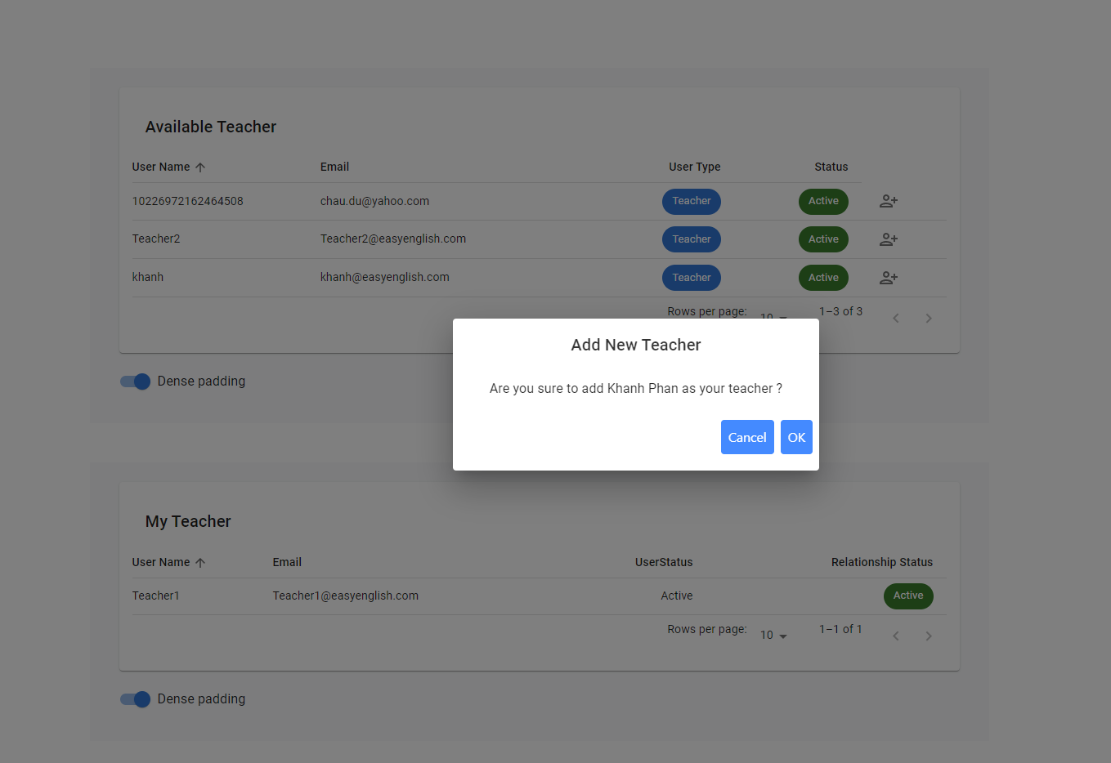

8 As a teacher you can manage your student, manage your lessons (add/remove/edit lessons)

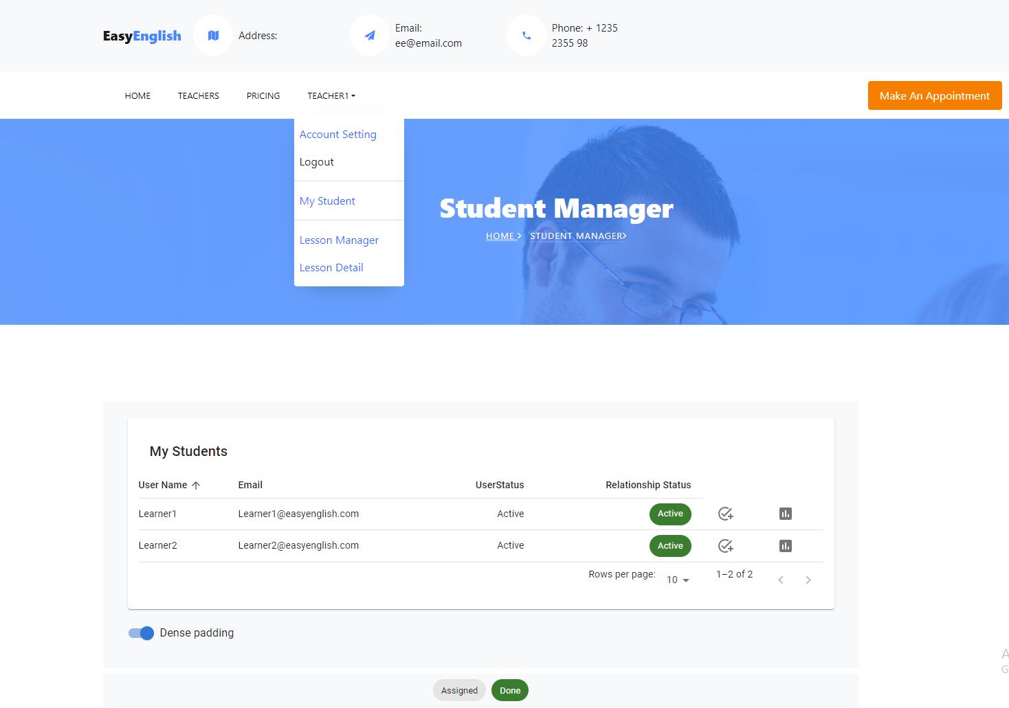

You can view a list of your students, which lessons that they are working on and view their results and provide feedback for your students.

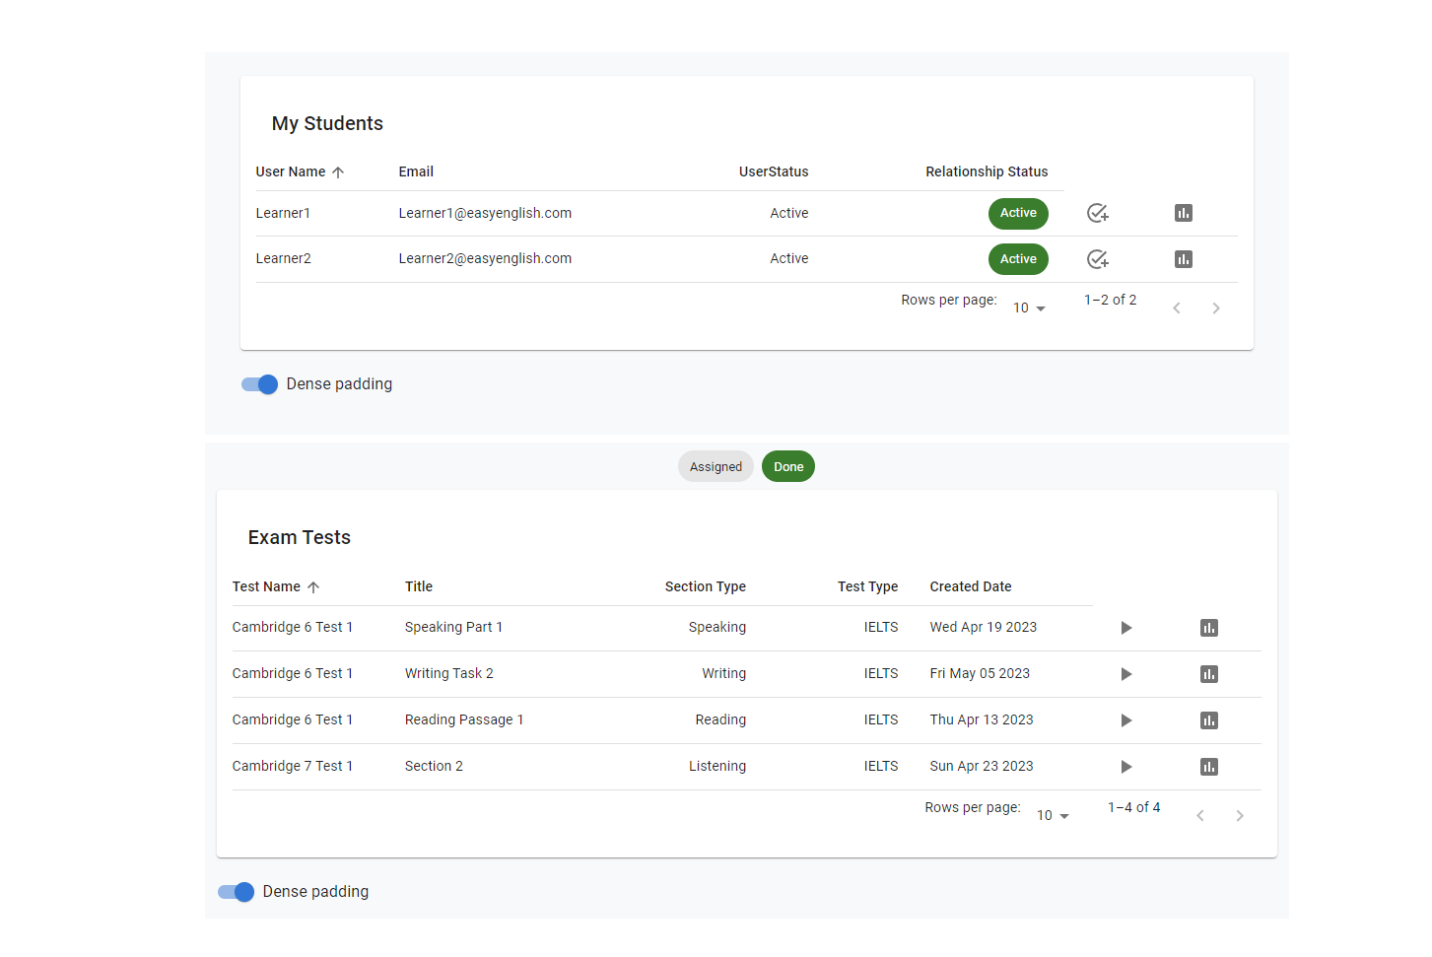

Assigned Tests/Lessons for your students:

View their work and provide feedback (only teacher can provide feedback, student can only view)

Teachers can also add/remove/edit their lessons.

Edit form

9. The final role is admin, which can manage user/tests and can also be a student.

Manage Tests (can be IELTS/PTE/General English). At this moment, we primarily focus on IELTS. But we are subject to expand to all kinds of tests which can support students on their study aboard journeys.

Add new IELTS/PTE/GE Tests form.

Manage users: admin can decide who is the users or teachers.

I’m thinking to have a booking appointment function that allows students to arrange time with teachers effective so student and teachers can avoid the hassle of conflict in time scheduling which will be a tremendous problem of online study.

We can setup the list of teachers, students, and prices…. But due to lack of information, I put it on hold.